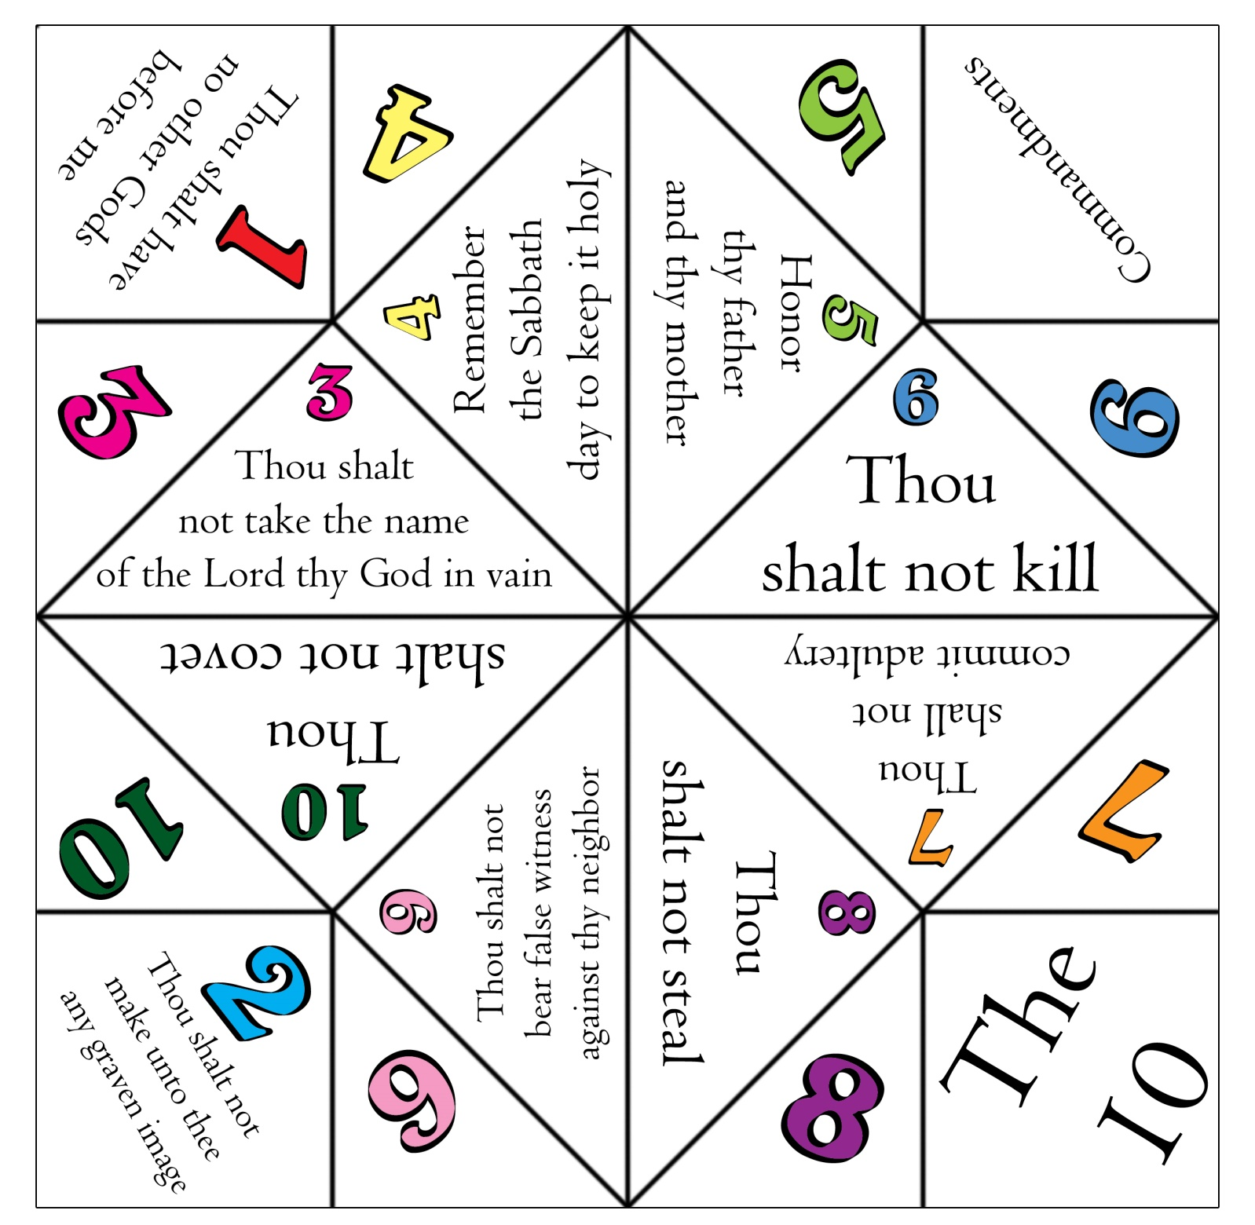
How to link
http://www.rachaelsbooknook.net/10-commandments-foldable/

